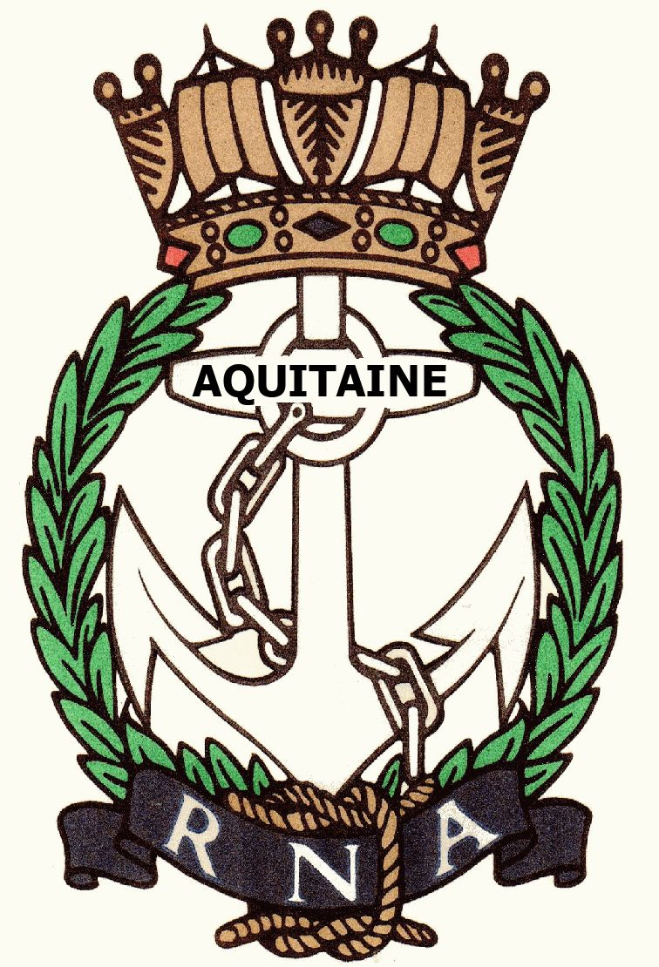
AQUITAINE BRANCH – ROYAL NAVAL ASSOCIATION
Chairman Shipmate Ken Napier MBE
Chazarem, 47290 Beaugas
Email napier.chazarem@wanadoo.fr www.rna-aquitaine.com Tel 05 53 01 72 80

MINUTES OF THE ANNUAL GENERAL MEETING HELD AT LE SEMILLON, MONBAZILLAC
ON WEDNESDAY 11TH MARCH 2020

- PRESENT: Mike Brookes, Val Clarke, Chris Haskell, Gareth Mulloy, Ken Napier, Sue Napier, Ray Pemble, Di Pemble, Don Pike, Dave Rolfe, Liz Rolfe, David Rollston-Smith, Anne Scanlan, Neil Wilde, Julie Wilde

- APOLOGIES: Richard Amott, Joan Amott, Ken Ayling, Chris Barnacle, Steve Collins, Antoinette Henry, Brian Johnson, Jill Johnson, Jeannette Kastelein, John Larmuth, Angela Larmuth, Didier Villiers, Martine Villiers

- APPROVAL OF MINUTES FROM AGM 2019: The minutes of the last AGM were approved; Proposed Don Pike, seconded Dave Rolfe

- ELECTION OF COMMITTEE: The Committee for 2019 were all willing to restand for election for 2020 and were unanimously elected. Proposed David Rollston-Smith, seconded Liz Rolfe.. The post of Asst Secretary remains vacant and the Chairman pointed out that a new Treasurer would be required for next year.

- CHAIRMAN’S REPORT: In the absence of his written report the Chairman gave a verbal report. His full report is attached along with these minutes.

- TREASURER’S REPORT: The Treasurer reported:

Total income for the year was 2854€ - from subs, raffle and miscellaneous.
Total expenditure was 2101€ - including charitable grants, subs to HQ and miscellaneous

Profit for the year was 753€ - this includes the 216€ received after Dave Pegg’s funeral

In the current account 1072€
In the Livret A 2776€

Auditors for 2020 Sue Napier and Mike Brookes/Dave Rolfe if Mike Brookes is not available

- REORGANISATION OF BANK ACCOUNTS: The Treasurer recommended that given the very low interest rates paid on the Livret A that we reduce the ‘emergency fund’ to 1500€ and move all the money to the current account. This would simplify the banking and free up 2000€ for charitable donations. This was put to the committee and unanimously agreed. Proposed David Rollston-Smith, seconded Ray Pemble.

- ALLOCATION OF FUNDS 2020: It was agreed that as usual we would divide the 2000€ available for charitable contributions between the 4 charities – RNBT, WRNSBT, ARNO and SSAFA France. The 216€ from Dave Pegg’s funeral will be sent to the RNBT in his name. A copy of the accompanying letter will be sent to HMS GANGES ASSOCIATION as Dave was a staunch supporter of the Association and always attended their reunions. Proposed Liz Rolfe, seconded Sue Napier.

AQUITAINE BRANCH – ROYAL NAVAL ASSOCIATION
Chairman Shipmate Ken Napier MBE
Chazarem, 47290 Beaugas
Email napier.chazarem@wanadoo.fr www.rna-aquitaine.com Tel 05 53 01 72 80

- MEMBERSHIP: Ken Ayling has put an ad in the online 47 magazine but this has produced no results. Members were asked to encourage any prospective members to come along to a lunch to ‘try us out’.

- SOCIAL PROGRAMME: The date for Trafalgar lunch was set for Wednesday 14th October at La Braise in Bergerac, unless another venue suggests itself during the year. It was proposed that we ask the Naval Attaché if he is free to come as a speaker.
The April lunch will be organised as usual –venue to be confirmed – but will only go ahead if coronavirus conditions allow.

- ANY OTHER BUSINESS: Ray Pemble requested that when possible we send out the menu with the newsletter.
Liz Rolfe asked if members have been given house numbers in the recent changes of addresses could people let us know please.

David Rollston-Smith proposed a vote of thanks to Ken and Sue for their work over the year.

The meeting closed at 11.46

COMMITTEE

Chairman - Ken Napier
Vice Chairman - Ken Ayling
Secretary - Sue Napier
Asst Secretary -
Treasurer - Don Pike
Asst Treasurer - Ray Pemble
Welfare - Liz Rolfe

